**Back-End Web Development Training Report**

An Internship Project Report

Under Subject

**Internship/Project (31832001)**

**Semester-VIII**

Submitted By

**Parth Anilbhai Nakum**

190040107033

*In partial fulfilment for the award of the degree of*

**Bachelor of Engineering (8th Sem)**

in

**Computer Science and Engineering**

**B.H Gardi College of Engineering & Technology, Rajkot**





**Gujrat Technological University**

[Fab 1st – Apr 30th]



**B.H Gardi College of Engineering & Technology, Rajkot**

# CERTIFICATE

This is to certify that the project report submitted along with the project entitled **Back-End Web Developer Training** has been carried out by **Parth Anilbhai Nakum** under my guidance in partial fulfilment for the degree of Bachelor of Engineering in , 8th Semester of Gujarat Technological University, Ahmadabad during the academic year 2022-23.

Varsha Oberoi Ms. Monika Shah Ms. Monika Shah

External Guide Internal Guide Head of Department



**B.H Gardi College of Engineering & Technology, Rajkot**

# DECLARATION

We hereby declare that the Internship submitted along with the Internship entitled **Back-End Web Developer Training** submitted in partial fulfilment for the degree of Bachelor of Engineering in **Computer Science and Engineering** to Gujarat Technological University, Ahmedabad, is a bonafide record of original project work carried out by me at **Radix software services Pvt Ltd** under the supervision of and that no part of **Valarsh Oberoi** as **External Guide** & **Ms. Monika Shah** as **Internal Guide** this report has been directly copied from any students’ reports or taken from any other source, without providing due reference.

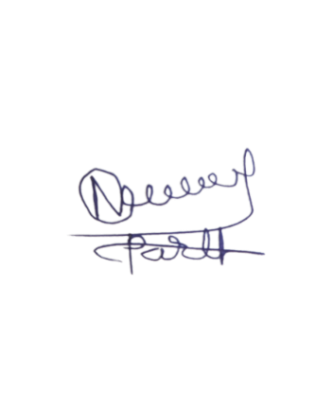

**Name of Student**

Parth Anilbhai Nakum Signature of Student

# Acknowledgement

I would like to express my heartily thanks with a deep sense of gratitude and respect to all those who has provided me immense help and guidance during my project. I would like to express my sincere thanks to my trainer or External Guide **Varsha R Oberoi** for providing vision about the industry and for giving me an opportunity to undertake such a great challenging and innovative work. I would to extends to thanks **Radix software services Pvt Ltd, Ahmedabad** to provide me to opportunity of internship. I am grateful for the guidance, encouragement, understanding, and insightful support given in the development process.

I would like to extend my gratitude to **Ms. Monika Shah** Internal Guide of this training & **Ms. Monika Shah** Head of Computer Engineering B.. Gardi College of Engineering & Technology, Rajkot for his continuous encouragement and motivation.

Last but not the least I would like to mention here that I am greatly indebted to each and everybody who has been associated with training at any stage but whose name does not find a place in this acknowledgement and lastly, Thank you so much.

**You’re Sincerrly**

**Parth Anilbhai Nakum**

# Chapter 1 - Introduction

## Introduction to web Technology Stack

### **Web development**

Web development is the art and science of creating and maintaining websites that work on the internet or private networks. Web development refers to the creating, building, and maintaining of websites. It includes aspects such as web design, web publishing, web programming, and database management. It is the creation of an application that works over the internet i.e., websites.

Web developers use various languages and tools to design, code, and test the web pages, such as HTML, CSS, JavaScript, PHP, and more.

Web development can be divided into three main categories: front-end, back-end, and full-stack

* **Front-end** development deals with the appearance and interaction of the web pages, using languages like HTML, CSS, and JavaScript.
* **Back-end** development handles the logic and data of the web pages, using languages like PHP, Python, Ruby, and more.
* **Full-stack** development combines both front-end and back-end skills, and can create complete web applications from scratch

### **Full Stack Web Development**

**Front End**

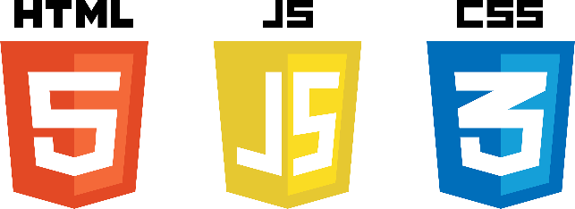It refers to the development of both front end (client side) and back end (server side) portions of web application.

* **Front End Technologies HTML**
* HTML
* CSS
* JavaScript

Figure 1 Front End Technology

* **Front End Frameworks**
* Angular
* React Js
* Bootstrap
* Tailwind
* JQuery
* SASS

**Back End**

It refers to the server-side development of web application or website with a primary focus on how the website works. It is responsible for managing the database through queries and APIs by client-side commands. This type of website mainly consists of three parts front end, back end, and database

* 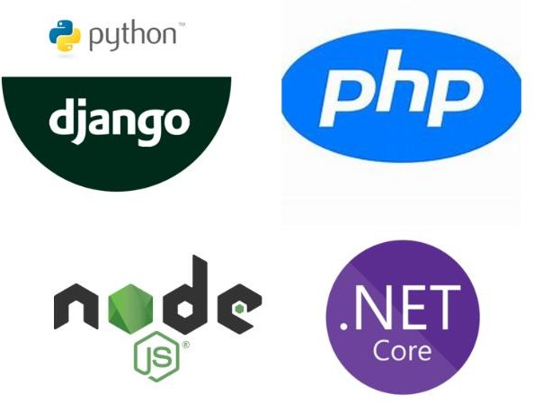**Back End Technologies**

Figure 2 Back End Technology

* PHP
* C++
* NodeJS
* .NET
* Python

**Tools for the Web development**

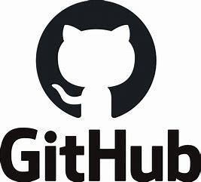For every War we required the Weapon, Same as for web development we required the tools as a weapon. In Radix web we follow the SOP for development. As per SOP we required Quality first, so that for Quality development We used as follow tools

* For Project Management: Redmine
* For Creating Code: Visual Studio Code
* For Version Control: Git Hub
* 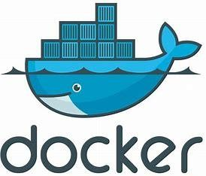For Quality Deployment: Docker
* For Quality Check: SonarQube
* For network deploy: Netlify / Stack blitz

Figure 3 Tool For the Web development

# Chapter 2 – GIThub

## Version Control System

Let assume, you work with major project with multiple developer. Let say you have one of the developers, suppose you created the Navbar and Other developer needs it. Now you share your code with Classical way by ZIP. Some what you’re working strategy is okay, but in case of full development you need to share your code every time, and compare with other code also. So, this way is so frustrating. Now we need some special kind of tool. This tool called as a Version Control System.

### **Version Control System**

We can define Version control systems as They are a category of software tools that helps in recording changes made to files by keeping a track of modifications done in the code. A version control system is a kind of software that helps the developer team to efficiently communicate and manage (track) all the changes that have been made to the source code along with the information like who made and what changes have been made.

**Benefit of VCS**

* Enhances the project development speed by providing efficient collaboration.
* Leverages the productivity, expedites product delivery, and skills of the employees through better communication and assistance.
* Reduce possibilities of errors and conflicts meanwhile project development through traceability to every small change.
* Employees or contributors of the project can contribute from anywhere irrespective of the different geographical locations through this VCS.
* Helps in recovery in case of any disaster or contingent situation,

### **Types of Version Control System**

1. Local Version Control System
2. Centralized Version Control System
3. Distributed Version Control System

**Local Version Control System** is the one of the simplest forms and has a database that kept all the changes to files under revision control.

**Centralized version control systems** contain just one repository globally and every user need to commit for reflecting one’s changes in the repository. It is possible for others to see your changes by updating.

**Distributed version control systems** contain multiple repositories. Each user has their own repository and working copy. Just committing your changes will not give others access to your changes.

### Git Vs. GitHub: Demystifying the Differences - DZone Open Source**GitHub**

Figure 4 GitHub [Version control Tool]

Git is a specific open-source version control system created by Linus Torvalds in 2005.

Specifically, Git is a **distributed version control system**, which means that the entire codebase and history is available on every developer’s computer, which allows for easy branching and merging.

### **Chapter Task**

**Module Name: Redmine Git - 1.0**

**Day – Task**

**Assignment – 1**

Create a flow chart and algorithm for addition of two numbers, area of circle, do the sum of all the even numbers.

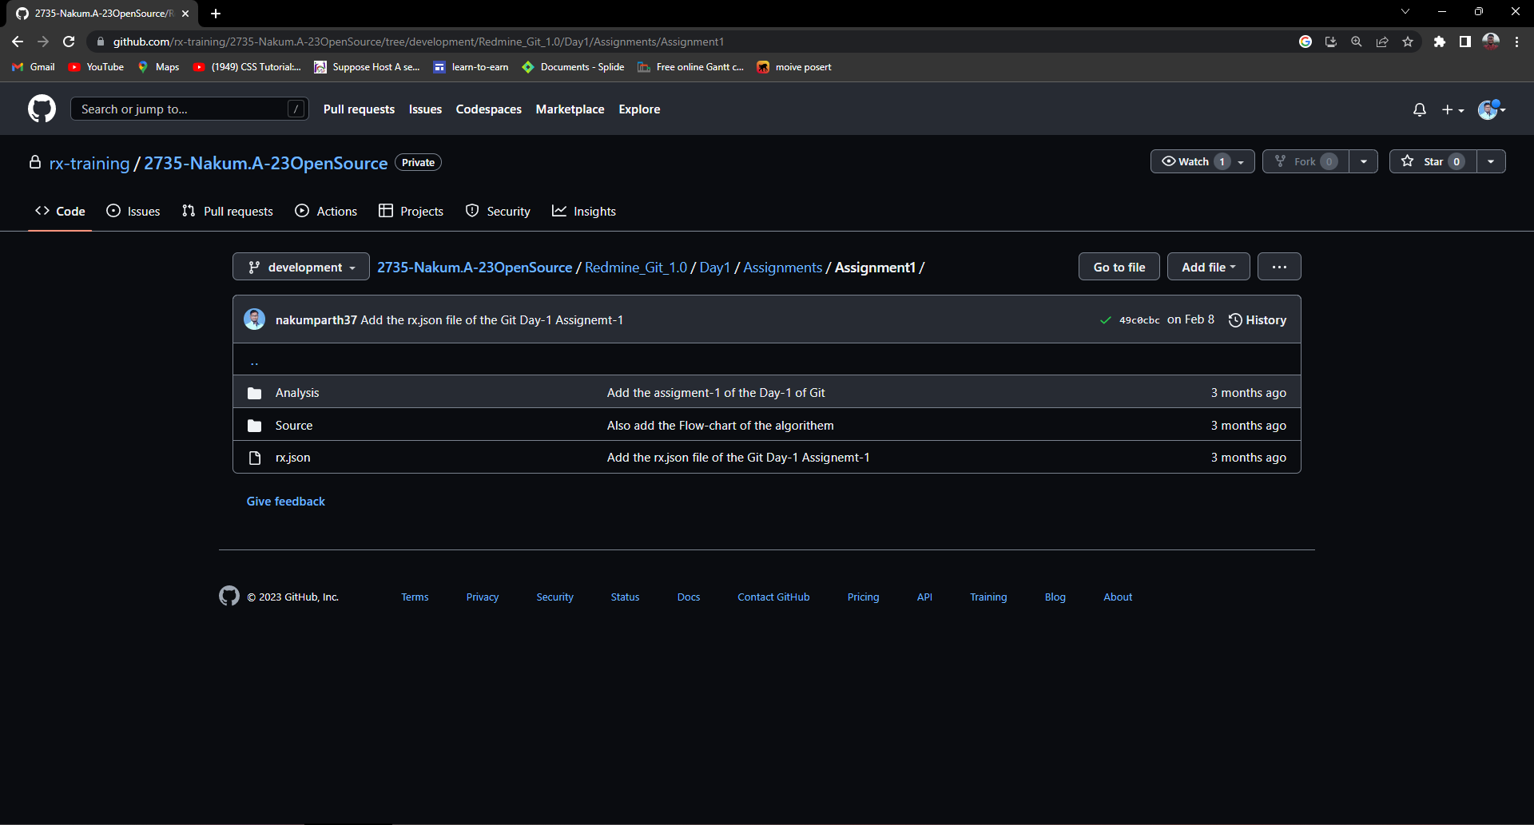

Figure 5 GitHub day-1 Assignment-1

**Assignment – 2**

Fork the following repository and Practice to conflict.

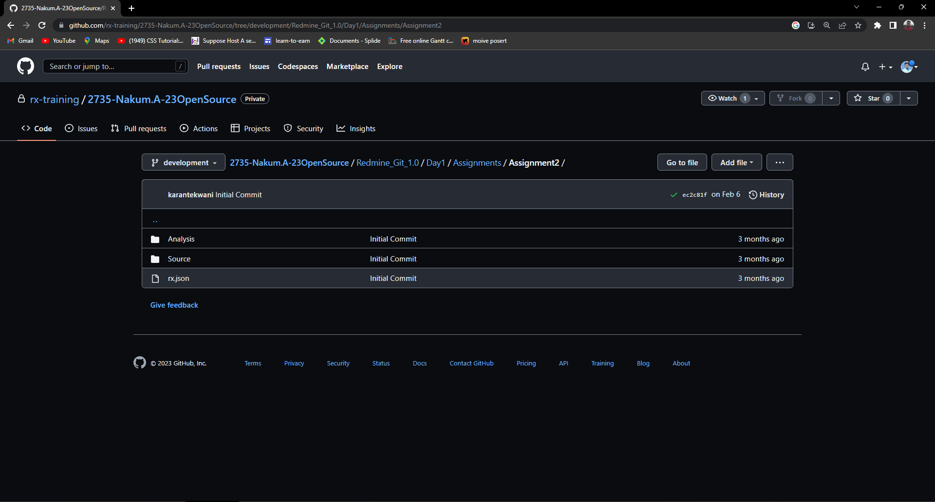

Figure 6 GitHub Day-1 Assignmnet-2

# Chapter 3 – HTML

## Skeleton of Webpage

As per Our Human Body, we have Bone Skeleton. This is basic building block of our Human Body. Similarly In Websites there is main building block is Markup Page. This markup page usually designs by language called Hyper Text Markup Language (HTML).

### **HTML**

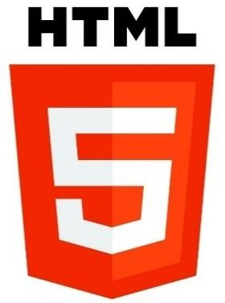HTML is the combination of Hypertext and Markup

language. Hypertext defines the link between the web pages and markup language defines the text document within the tag that define the structure of web pages.

HTML is used to create the structure of web pages that are displayed on the World Wide Web (www). It contains Tags and Attributes that are used to design the web pages. Also, we can link multiple pages using Hyperlinks

### **HTML Basic Page format Structure**

The basic structure of an HTML page is laid out below. It contains the essential building-block elements (i.e. doctype declaration, HTML, head, title, and body elements) upon which all web pages are created.

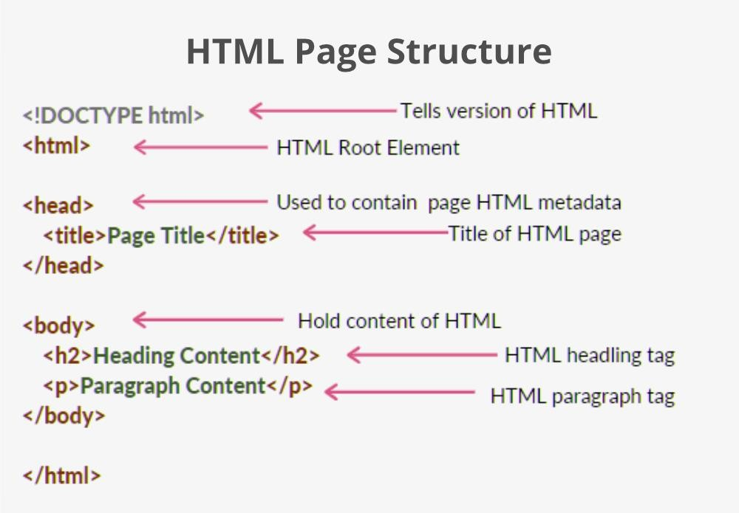

Figure 7 HTML Structure

### Chapter Task

**Module Name: FT-HTML 1.0**

**Day – Task**

**Assignment – 1**

Design a form for storing employee details. (Employee name, age, Gender, designation, salary, location, Email ID, Date of Joining and contact number)

* + Validation required.
  + Age should be a number.
  + Each field should contain value
  + Email ID should be in proper format
  + Date of joining should be in date format
  + Location should be in the drop down list
  + Use radio buttons for Gender.

Work

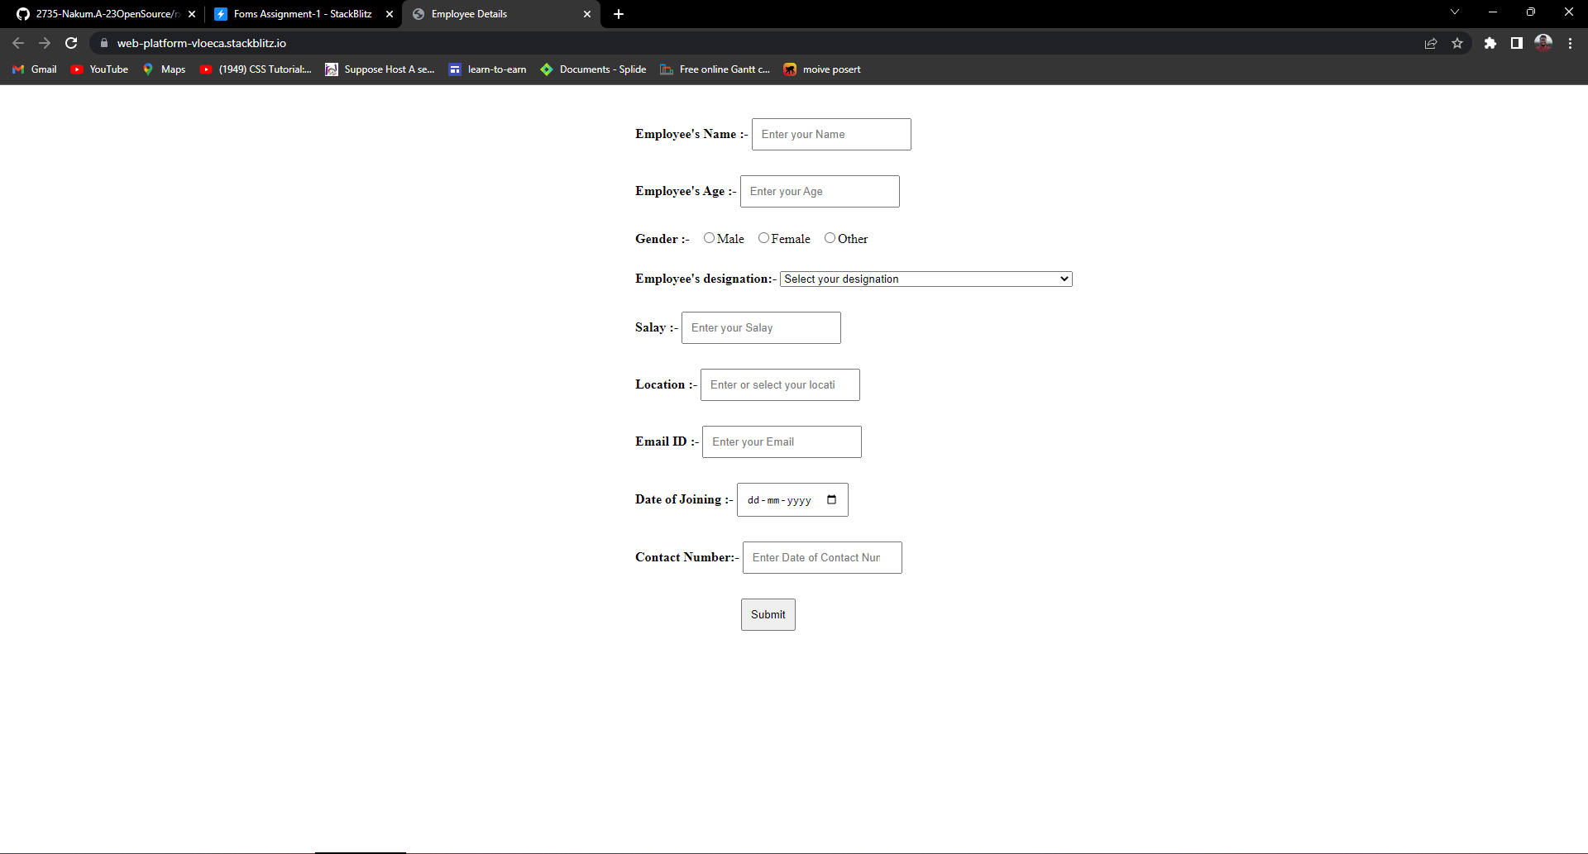

Figure 8 HTML Day-1 Assignment-1

**Assignment – 2**

Create personalized resume, which must be attractive. Use all the HTML tags and add one short video of your project done into resume.

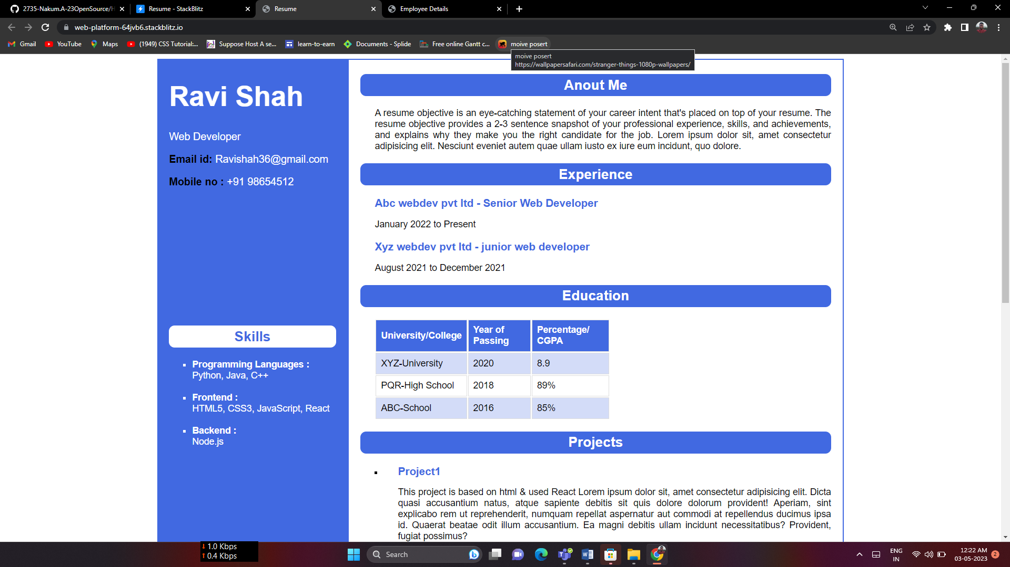

Figure 9 HRML Day-2 Assignment-1